Beyond niche news: multi-level examination of individual, group, and organizational effects on ideological news consumption

Working RQs

RQ1: What are the potential patterns of niche news consumption in the overall attention network?

RQ2: What is the relationship between a) individual-level b) niche-level, and c) organizational attributes on ideological news consumption?

RQ3: How does news use on social media shape news ideology?

Figure 1

*Network Projection from Cluster Analysis*

Table 1

*Organizational Niche Membership*

|  |  |  |  |  |  |
| --- | --- | --- | --- | --- | --- |
| **Niche 1** | | **Niche 2** | | **Niche 3** | |
| *Right-Leaning Cable & TV* | | *Left-Leaning Online Elite Press* | | *Local/Aggregators* | |
| ABC*  BBC*  Breitbart  CBS*  CNBC*  CNN*  Fox | LA Times*  MSNBC*  NBC*  Newsmax  NY Post  OAN  Right Sphere  Univision* | Huffington Post  NY Times  Washington Post  Politico  NPR*  Buzzfeed  International Media*  Wall Street Journal*  New Magazines*  PBS*  Left Sphere |  | Aggregators  Chicago Tribune  Local Paper  Local Radio  Local TV  Local Web  MSN  Neutral Sphere  Social Agg. | USA Today  Yahoo |
| *Note:* * Indicates deviations from theoretical expectations. | | | | | |

|  |  |  |  |  |
| --- | --- | --- | --- | --- |
| Table 2  *Means and Variances for News Ideology at the Organization and Individual Levels* | | | | |
| Statistic | Local/Aggregators | Elite | Cable | Full Sample |
| **Organizational Level** | | | | |
| Mean | -0.10 | -0.79 | 0.41 | -0.10 |
| Variance | 0.09 | 0.27 | 1.88 | 1.08 |
| *N* | 11 | 11 | 15 | 37 |
| Between-Group Variance | 4.57 | | | |
| Within-Group Variance | 0.88 | | | |
| Test Statistic | *F* (2) = 5.19, *p* = 0.011 | | | |
| **Individual Level** | | | | |
| Mean | -0.07 | -0.73 | 0.03 | -0.10 |
| Variance | 0.15 | 0.15 | 0.79 | 0.62 |
| *N* | 344 | 195 | 905 | 1,444 |
| Between-Group Variance | 41.29 | | | |
| Within-Group Variance | 0.51 | | | |
| Test Statistic | *F* (2) = 81.20, *p* < .001 | | | |
| *Note*: Response variable has theoretical range of 6 (Min. = -3 ‘far left’ and Max. = 3 ‘far right’) and an observed range of 5.0 (Min. = -2.0, Max. = 3.0). Data weighted by education and income. | | | | |

Figure 2

*Boxplot of News Ideology at the Organizational and Individual Levels*

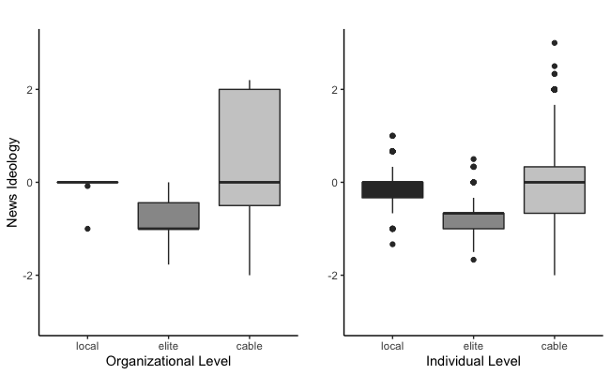

|  |  |  |  |  |  |  |  |  |  |  |  |  |
| --- | --- | --- | --- | --- | --- | --- | --- | --- | --- | --- | --- | --- |
| Table 3  *The Predictors of News Ideology at the Individual, Audience, and Organizational Levels* | | | | | | | | | | | | |
|  | Model 1 | | | Model 2 | | | Model 3 | | Model 4 | | Model 5 | |
| **Fixed Effects** | *b* | | *SE* | *b* | *SE* | | *b* | *SE* | *b* | *SE* | *b* | *SE* |
| Intercept | -0.21*** | | 0.05 | -0.14*** | 0.03 | | 0.00 | 0.03 | -0.14*** | 0.03 | 0.00 | 0.03 |
| Age | -0.04*** | | 0.01 | -0.04*** | 0.01 | | -0.04*** | 0.01 | -0.04*** | 0.01 | -0.04*** | 0.01 |
| Gender (1 = Female) | 0.01 | | 0.04 | 0.00 | 0.04 | | 0.00 | 0.04 | 0.00 | 0.04 | 0.00 | 0.04 |
| Race (1 = Person of Color) | -0.15*** | | 0.04 | -0.15*** | 0.04 | | -0.16*** | 0.04 | -0.15*** | 0.04 | -0.15*** | 0.04 |
| Education | -0.01 | | 0.01 | -0.01 | 0.01 | | -0.01 | 0.01 | -0.01 | 0.01 | -0.01 | 0.01 |
| Income | 0.00 | | 0.01 | 0.00 | 0.01 | | 0.00 | 0.01 | 0.00 | 0.01 | 0.00 | 0.01 |
| Political Interest | -0.04* | | 0.02 | -0.04* | 0.02 | | -0.04* | 0.02 | -0.04* | 0.02 | -0.04* | 0.02 |
| Individual Ideology | 0.06*** | | 0.01 | 0.06*** | 0.01 | | 0.06*** | 0.01 | 0.06*** | 0.01 | 0.07*** | 0.01 |
| **Contextual Effects** | *b* | | *SE* | *b* | *SE* | | *b* | *SE* | *b* | *SE* | *b* | *SE* |
| Audience Ideology |  | |  | 0.43*** | 0.04 | |  |  | 0.44*** | 0.04 |  |  |
| Organization Ideology |  | |  |  |  | | 1.02*** | 0.09 |  |  | 1.03*** | 0.09 |
| **Interactions** | *b* | | *SE* | *b* | *SE* | | *b* | *SE* | *b* | *SE* | *b* | *SE* |
| Individual Ideology *  Audience Ideology |  | |  |  |  | |  |  | 0.02# | 0.01 |  |  |
| Individual Ideology * Organization Ideology |  | |  |  |  | |  |  |  |  | 0.08** | 0.03 |
| **Random Effects** | *Var*. | | | *Var.* | | | *Var.* | | *Var.* | | *Var.* | |
| Intercept Niche:Frame | 0.09 | | | 0.01 | | | 0.01 | | 0.01 | | 0.01 | |
| Individual Ideology | 0.00 | | | 0.00 | | | 0.00 | | 0.00 | | 0.00 | |
| Residual | 0.45 | | | 0.44 | | | 0.44 | | 0.44 | | 0.44 | |
| **Fit Statistics** |  |  | |  | |  |  |  |  | |  | |
| LR | -1,720.00 | | | -1,686.47 | | | -1,685.37 | | -1,688.34 | | -1,684.30 | |
| ICC | 0.17 | | | 0.02 | | | 0.02 | | 0.03 | | 0.02 | |
| *Notes*: Cell entries are parameter estimates from multilevel models (MLM) with random intercepts.  *N* = 1,444. Groups = 51 (3 niches by 17 frames). #*p* < .10,\**p* < .05, \*\**p* < .01, \*\*\**p* < .001. Data weighted by education and income. Variables are group-mean centered. | | | | | | | | | | | | |

Figure 3

*Dot-and-Whisker Plot Showing Effects on News Ideology at the Individual, Audience, and Organizational Levels*

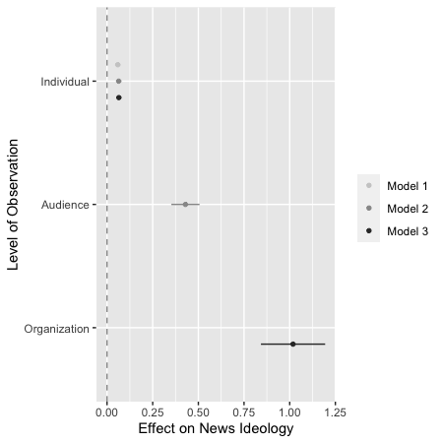

Figure 4

*Conditional Effects of Individual Ideology at Various Levels of Audience and Organizational Ideology*

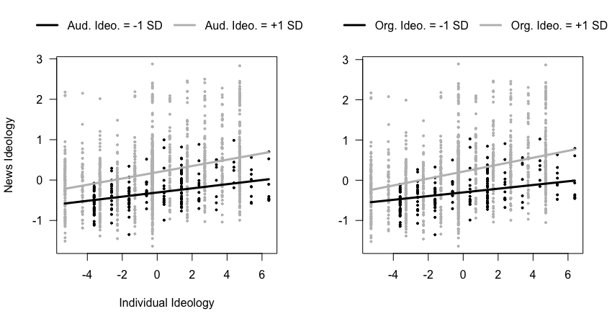

|  |  |  |  |  |  |  |
| --- | --- | --- | --- | --- | --- | --- |
| Table 4  *Effects of Social Media Variables on News Ideology* | | | | | | |
|  | Model 6 |  | Model 7 |  | Model 8 |  |
| **Fixed Effects** | *b* | *SE* | *b* | *SE* | *b* | *SE* |
| Intercept | -0.51*** | 0.09 | -0.48*** | 0.09 | -0.46*** | 0.09 |
| Age | -0.05*** | 0.01 | -0.05*** | 0.01 | -0.05*** | 0.01 |
| Gender (1 = Female) | -0.01 | 0.04 | -0.01 | 0.04 | -0.01 | 0.04 |
| Race (1 = Person of Color) | -0.15*** | 0.04 | -0.14*** | 0.04 | -0.148** | 0.04 |
| Education | -0.01 | 0.01 | -0.01 | 0.01 | -0.01 | 0.01 |
| Income | 0.00 | 0.01 | 0.00 | 0.01 | 0.00 | 0.01 |
| Political Interest | -0.03 | 0.02 | -0.03 | 0.02 | -0.03 | 0.02 |
| Individual Ideology | 0.07*** | 0.01 | 0.04** | 0.01 | 0.03 | 0.02 |
| Frequency of Use | 0.02 | 0.01 | 0.01 | 0.01 | 0.02 | 0.01 |
| Network Size | -0.05* | 0.02 | -0.04 | 0.02 | -0.05* | 0.02 |
| Network Diversity | 0.07 | 0.09 | 0.07 | 0.09 | 0.07 | 0.09 |
| News Follows | -0.03 | 0.02 | -0.02 | 0.02 | -0.02 | 0.02 |
| Incidental News Exposure | 0.02 | 0.03 | 0.02 | 0.03 | 0.01 | 0.03 |
| Algorithmic Categorization  (1 = Interested) | -0.02 | 0.04 | -0.02 | 0.04 | -0.02 | 0.04 |
| **Contextual Effects** | *b* | *SE* | *b* | *SE* | *b* | *SE* |
| Audience Engagement | 0.80*** | 0.14 | 0.75*** | 0.15 | 0.78*** | 0.14 |
| Net Story Sentiment | 0.17 | 0.16 | 0.12 | 0.17 | 0.08 | 0.17 |
| **Interactions** | *b* | *SE* | *b* | *SE* | *b* | *SE* |
| Individual Ideology * Audience Engagement |  |  | 0.08*** | 0.02 |  |  |
| Individual Ideology *  Net Story Sentiment |  |  |  |  | 0.07* | 0.03 |
| **Random Effects** | *Var*. | | *Var.* | | *Var.* | |
| Intercept Niche:Frame | 0.03 | | 0.04 | | 0.03 | |
| Individual Ideology | 0.00 | | 0.00 | | 0.00 | |
| Residual | 0.45 | | 0.45 | | 0.45 | |
| **Fit Statistics** |  |  |  |  |  |  |
| LR | -1,715.61 | | -1,713.07 | | -1,715.70 | |
| ICC | .06 | | 0.08 | | 0.06 | |
| *Notes*: Cell entries are parameter estimates from multilevel models (MLM) with random intercepts.  *N* = 1,444. Groups = 51 (3 niches by 17 frames). #*p* < .10,\**p* < .05, \*\**p* < .01, \*\*\**p* < .001. Data weighted by education and income. Variables are group-mean centered. | | | | | | |

Figure 5

*Conditional Effects of Individual Ideology at Various Levels of Audience Engagement and Net Story Sentiment*

